**Supplementary Material**

**S1: CFI items and sub-scale allocation**

CFI_1. I am good at ‘‘sizing up’’ situations.—(Alternatives) — removed

CFI_2. I have a hard time making decisions when faced with difficult situations.—(Control) reverse coded

CFI_3. I consider multiple options before making a decision.—(Alternatives)

CFI_4. When I encounter difficult situations, I feel like I am losing control.—(Control) reverse coded

CFI_5. I like to look at difficult situations from many different angles.—(Alternatives)

CFI_6. I seek additional information not immediately available before attributing causes to behavior.—(Alternatives)

CFI_7. When encountering difficult situations, I become so stressed that I can not think of a way to resolve the situation.—(Control) reverse coded

CFI_8. I try to think about things from another person’s point of view.—(Alternatives)

CFI_10. I find it troublesome that there are so many different ways to deal with difficult situations.—(Control) reverse coded

CFI_11. When I encounter difficult situations, I just don’t know what to do.—(Control) reverse coded

CFI_12. It is important to look at difficult situations from many angles.—(Alternatives)

CFI_13. When in difficult situations, I consider multiple options before deciding how to behave.—(Alternatives)

CFI_14. I often look at a situation from different viewpoints.—(Alternatives)

CFI_15. I am capable of overcoming the difficulties in life that I face.—(Control)

CFI_16. I consider all the available facts and information when attributing causes to behavior.—(Alternatives)

CFI_17. I feel I have no power to change things in difficult situations.—(Control) reverse coded

CFI_18. When I encounter difficult situations, I stop and try to think of several ways to resolve it.—(Alternatives)

CFI_19. I can think of more than one way to resolve a difficult situation I’m confronted with.—(Alternatives)

CFI_20. I consider multiple options before responding to difficult situations.—(Alternatives)

**S2: Testing the normal distribution of all continuous variables used in the original study**

**Table S1**

***Test statistics to assess normal distribution***

|  |  |  |  |  |  |  |  |  |
| --- | --- | --- | --- | --- | --- | --- | --- | --- |
|  | **Willingness to fight** | **Willingness to die** | **Certainty in trolley dilemma** | **RAT** | **WCST** | **CFI - Alternatives** | **CFI - Control** | **Normative pro-group behaviour** |
| **Skewness** | 1.70 | 1.08 | -0.37 | -0.65 | -2.01 | -0.65 | -0.18 | 0.51 |
| **Skewness.2SE\*** | 12.92 | 8.20 | -2.80 | -4.92 | -15.22 | -4.92 | -1.37 | 3.90 |
| **Kurtosis** | 3.61 | 0.45 | -0.95 | 0.28 | 4.59 | 1.11 | -0.42 | -0.43 |
| **Kurtosis.2SE\*** | 13.71 | 1.69 | -3.60 | 1.05 | 17.43 | 4.20 | -1.58 | -1.64 |
| **Shapiro-Wilk test statistic: *W, p*** | .82, *p* = .000 | .82, *p* = .000 | .94, *p* = .000 | .96, *p* = .000 | .79, *p* = .000 | .97, *p* = .000 | .99, *p*  = .000 | .95, *p*  = .000 |

***Note. \** =** values larger than one indicate significance

**Figure S1**

***Q-Q plots***

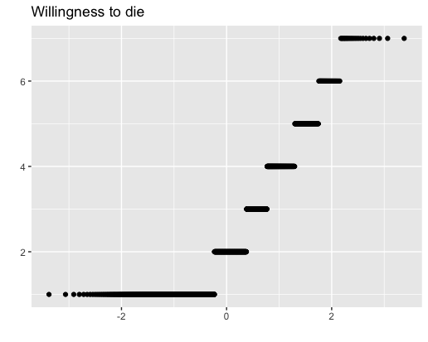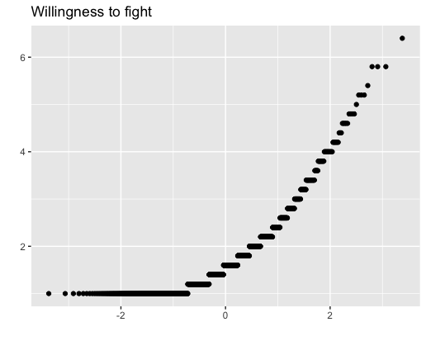

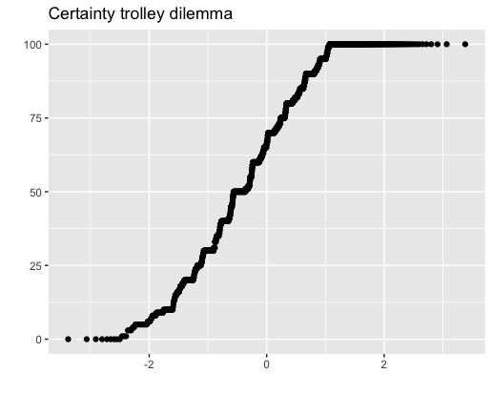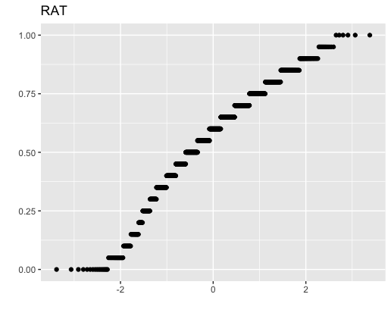

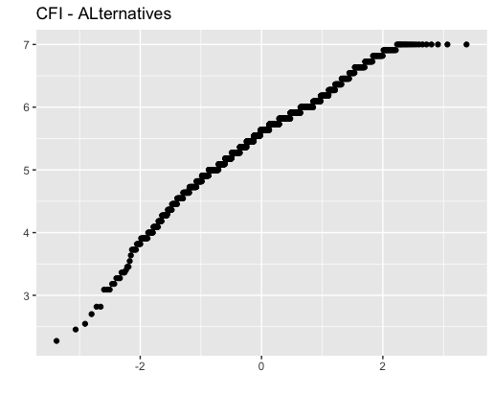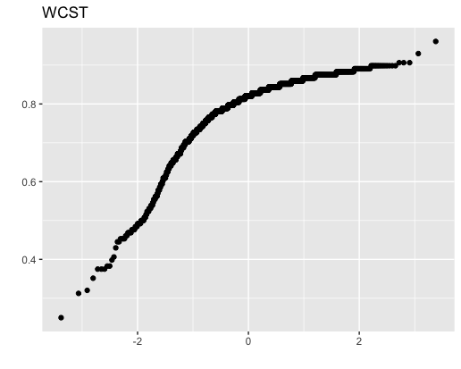

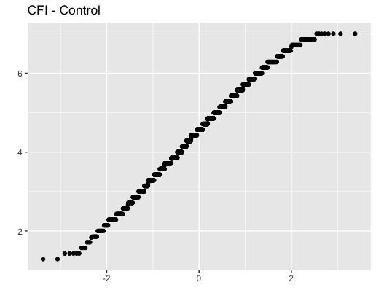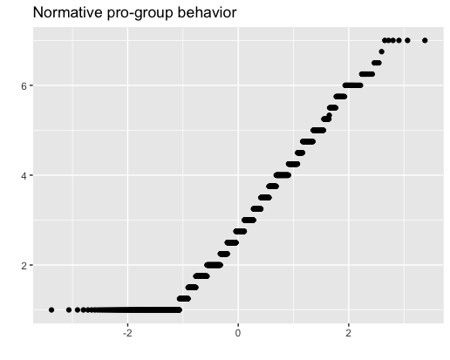

**S3: Results of the parametric hypothesis tests**

*Hypothesis 1*

To assess whether cognitive flexibility was negatively related to support for violent extremism, we examined bivariate correlations between WCST and RAT accuracy rates, willingness to fight and willingness to die for the ingroup. Hypothesis 1 was partially supported as RAT accuracy rates were significantly negatively correlated with both willingness to fight and die for the group (Table S2). However, this result pattern did not replicate the findings of the original study. In our study, WCST accuracy rates were not significantly, negatively correlated with willingness to fight. Further, the correlation coefficients between RAT accuracy rates and willingness to die and fight reported in the original study (*r* = -.207, *p =* .001; *r* = -.241, *p* < .001 respectively) were not included in the 95% confidence intervals of the coefficients identified in our data.

**Table S2**

***Descriptive statistics and bi-variate correlations (95% CI are presented in brackets)***

|  |  |  |  |  |  |  |  |  |
| --- | --- | --- | --- | --- | --- | --- | --- | --- |
| Variable | | M | SD | 1 | 2 | 3 | 4 | 5 |
| 1 -Willingness to die | 2.32 | | 1.49 | 1 |  |  |  |  |
| 2 - Willingness to fight | 1.75 | | 0.82 | .47***  (.43, .51) | 1 |  |  |  |
| 3 - Certainty trolley dilemma | 62.91 | | 28.31 | -.14***  (-.19, -.09) | .01  (-.05, .06) | 1 |  |  |
| 4 - RAT | 0.57 | | 0.20 | -.10***  (-.15, -.04) | -.09***  (-.14, -.04) | .02  (-.04, .07) | 1 |  |
| 5 - WCST | 0.79 | | 0.10 | .05  (-.004, .10) | -.03  (-.08, .02) | -.01  (-.06, .05) | .21*** (.16, .26) | 1 |

Note. *** *p* < .001

*Hypothesis 2*

Table S3 shows that none of the pre-registered models attained acceptable model fit. Therefore, the hypothesis cannot be assessed. The finding of the original study regarding the outcome ‘willingness to die’ was not replicated; the result pattern for the outcome variable ‘choice in the trolley dilemma’ replicated the original study.

**Table S3**

***Model fit indices to test Hypothesis 2***

|  |  |  |  |  |
| --- | --- | --- | --- | --- |
| Fit index | Outcome: Willingness to die | Outcome: Willingness to die | Outcome: Choice trolley dilemma | Outcome: Choice trolley dilemma |
|  | Model 1 | Model 2 | Model 1* | Model 2* |
| χ2 test | χ2(11) = 186.09,  p = .000 | χ2(11) = 186.26,  p = .000 | χ2(4.64) = 77.83,  p = .000 | χ2(1.91) = 38.75,  p = .000 |
| CFI | 0.71 | 0.71 | 0.51 | 0.75 |
| RMSEA [90% CI] | .11 [.10, .12] | .11 [.10, .12] | N/A | N/A |
| SRMR | 0.07 | 0.07 | 0.06 | 0.10 |

*Note.* Model was not identified.

*Hypothesis 3*

Results showed that there was a difference in cognitive flexibility between the two groups (V = .01, *F*(2, 1375) = 9.00, *p* = .000). Participants who indicated that they would self-sacrifice had significantly lower RAT accuracy rates (*F*(1, 1376) = 17.61, *p* = .000; WCST: *F*(1, 1376) = 2.17, *p* = .141), which endorses the previous results. The finding did not replicate the original study where no between-subject differences on cognitive flexibility measures were reported.

Furthermore, in the whole sample, cognitive flexibility was not related to certainty in the decision in the trolley dilemma (Table S2). Sub-group analysis revealed that for those who chose to save themselves, greater conviction in the decision to self-sacrifice was not correlated with either WCST (*r* = .00, *p* = .991, 95% CI [-.06, .06]) or RAT (*r* = .03, *p* = .400, 95% CI [-.04, .09]) accuracy rates. For participants who indicated that they would self-sacrifice, RAT accuracy rates were significantly negatively correlated with conviction in the choice in the trolley dilemma (*r* = -.10, *p* = .044, 95% CI [-.19, -.00]). However, WCST accuracy rates did not correlate with certainty (*r* = -.05, *p* = .296, 95% CI [-.15, .04]).

*Additional Analyses Hypothesis 1*

To complement the aforementioned analyses assessing Hypothesis 1, bi-variate correlations between the Control and Alternatives scores of the CFI and willingness to fight (Alternatives: *r* = -.09, *p* = .001, 95% CI [-.14, -.03], Control: *r* = .10, *p* = .000, 95% CI [.05, .16]) and die for the ingroup (Alternatives: *r* = .08, *p* = .004, 95% CI [.02, .13], Control: *r* = .11, *p* = .000, 95% CI [.06, .16]) were calculated. Higher cognitive flexibility as measured by the Alternatives and Controls scale correlated with a *higher* willingness to die for the ingroup.

*Additional Analyses Hypothesis 2*

Adding to the analysis of Hypothesis 2, we extended the aforementioned two models such that Control and Alternatives scores were included as manifest, independent variables. Residual covariances were allowed between the two CFI scores, WCST, and RAT accuracy rates. In Model 1, additional direct paths between willingness to die/trolley dilemma behaviour, the willingness to fight for the group, as well as self-reported cognitive flexibility scores were specified. In Model 2, no direct path between the CFI scores and dependent variables were modelled; the association between self-reported cognitive flexibility and willingness to die/trolley dilemma behaviour was to be fully mediated by willingness to fight for the ingroup. Further to demographic variables, analyses controlled for identity fusion. In Model 1 and 2, direct paths between identity fusion (overlap score) and the two outcome variables were proposed; residual correlations were allowed between identity fusion and willingness to fight. Regarding both outcome variables - willingness to die and the choice in the trolley dilemma - neither Model 1 nor Model 2 provided optimal fit (Table S4).

**Table S4**

***Model fit indices for additional analyses of Hypothesis 2 (Part 1)***

|  |  |  |  |  |
| --- | --- | --- | --- | --- |
| Fit index | Outcome: Willingness to die | Outcome: Willingness to die | Outcome: Choice trolley dilemma | Outcome: Choice trolley dilemma |
|  | Model 1 | Model 2 | Model 1 | Model 2 |
| χ2test | χ2(26) = 412.36,  p = .000 | χ2(26) = 417.73,  p = .000 | χ2(25) = 469.82,  p = .000 | χ2(25) = 449.13,  p = .000 |
| CFI | 0.61 | 0.61 | 0.36 | 0.39 |
| RMSEA (90% CI) | .11 [.10, .11] | .11 [.10, .11] | .12 [.11, .12] | .11[.10, .12] |
| SRMR | 0.07 | 0.07 | 0.08 | 0.08 |

In the next step, we assessed Model 1 and 2 as described in the original study as well as the aforementioned extended Model 1 and 2 by considering normative pro-group behaviour intentions as the outcome variable. Once again, none of the examined models achieved acceptable model fit (Table S5). However, bi-variate correlations showed that normative pro-group behaviour was significantly negatively correlated with RAT (*r* = -.09, *p* = .001, 95% CI [-.14, -.04]) but not WCST accuracy rates (*r* = -.02, *p* = .439, 95% CI [-.07, .03]), replicating the relationship found between cognitive flexibility and support for violent extremism.

**Table S5**

***Model fit indices for additional analyses of Hypothesis 2 (Part 2)***

|  |  |  |  |  |
| --- | --- | --- | --- | --- |
| Fit index | Outcome: Normative pro-group behaviour | Outcome: Normative pro-group behaviour | Outcome: Normative pro-group behaviour | Outcome: Normative pro-group behaviour |
|  | Model 1 (original) | Model 2 (original) | Model 1 (adaption) | Model 2 (adaption) |
| χ2 test | χ2(11) = 186.09,  p = .000 | χ2(11) = 179.40,  p = .000 | χ2(26) = 412.36,  p = .000 | χ2(26) = 407.37,  p = .000 |
| CFI | 0.56 | 0.58 | 0.52 | 0.53 |
| RMSEA (90% CI) | .11 [.10, .12] | .11 [.09, .12] | .11 [.10, .11] | .10[.10, .11] |
| SRMR | 0.07 | 0.06 | 0.07 | 0.07 |

Hypothesis 3 was also extended by including the self-reported cognitive flexibility scores.

*Additional Analyses Hypothesis 3*

Hypothesis 3 was also extended by including the self-reported cognitive flexibility scores. We identified no difference for either outcome variable (Alternatives: *F*(1, 1376) = 1.31, *p* = .252; Control: *F*(1, 1376) = .52, *p* = .473) between participants who indicated that they would self-sacrifice vs. save themselves in the trolley dilemma. This result is in line with the results shown for WCST but not our evidence for RAT accuracy rates.

In the whole sample, certainty in the trolley dilemma decision was negatively correlated with Alternatives (*r* = -.08, *p* = .005, 95% CI [-.13, -.02]) and positively correlated with Control (*r* = .10, *p* = .000, 95% CI [.05, .16]) scores. The sub-group analysis showed that for those who chose to save themselves, the relationships were also significant (Alternatives: *r* = -.09, *p* = .003, 95% CI [-.16, -.03], Control: *r* = .11, *p* = .000, 95% CI [.04, .17]). In the sub-group that chose to self-sacrifice, only the sub-scale Control was significantly, *positively* related with conviction in the decision in the trolley decision (*r* = .11, *p* = .029, 95% CI [.01, .20]) (Alternatives: *r* = .00, *p* = .928, 95% CI [-.09, .10]). These findings reflect a surprising positive relationship between the Control sub-scale and certainty in the decision to self-sacrifice. The results do not replicate those achieved using the RAT and WCST accuracy rates.

**S4: MANOVA assumption tests**

**Table S6**

***Variance-covariance matrix per group – RAT and WCST***

|  |  |  |
| --- | --- | --- |
| **Group = save self** | WCST | RAT |
| WCST | 0.009 | 0.004 |
| RAT | 0.004 | 0.037 |
| **Group = self-sacrifice** | WCST | RAT |
| WCST | 0.011* | 0.005 |
| RAT | 0.005 | 0.043 |

*Note. \**variance ration is below the threshold 2

Test of multivariate normality was significant for both groups. Save self: *W* = .81, *p* = .000; sacrifice: *W* = .834, *p*  = .000

**Table S7**

***Variance-covariance matrix per group – CFI sub-scales***

|  |  |  |
| --- | --- | --- |
| **Group = save self** | Alternatives | Control |
| Alternatives | 0.566 | 0.184 |
| Control | 0.184 | 1.329 |
| **Group = self-sacrifice** | Alternatives | Control |
| Alternatives | 0.441* | 0.171 |
| Control | 0.171 | 1.299 |

*Note. \**variance ration is below the threshold 2

Test of multivariate normality was significant for both groups. Save self: *W* = .98, *p* = .000; sacrifice: *W* = .99, *p*  = .045

**S5: Conduct all pre-registered analyses with a sub-sample where those who failed the attention check (N = 9) are excluded**

**Table S8**

***Descriptive statistics and bi-variate correlations (95% confidence intervals are presented in brackets)***

|  |  |  |  |  |  |  |  |
| --- | --- | --- | --- | --- | --- | --- | --- |
| Variable | M | SD | 1 | 2 | 3 | 4 | 5 |
| 1 -Willingness to die | 2.31 | 1.49 | 1 |  |  |  |  |
| 2 - Willingness to fight | 1.75 | 0.83 | .47***  (.43, .51) | 1 |  |  |  |
| 3 - Certainty trolley dilemma | 62.93 | 28.30 | -.14***  (-.19, -.09) | .01  (-.04, .07) | 1 |  |  |
| 4 - RAT | 0.57 | 0.20 | -.09***  (-.15, -.04) | -.09***  (-.14, -.04) | .01  (-.04, .07) | 1 |  |
| 5 - WCST | 0.79 | 0.10 | .05  (.00, .10) | -.02  (-.08, .03) | -.01  (-.06, .04) | .21*** (.16, .26) | 1 |

Note. *** *p* < .001

**Table S9**

***Model fit indices to test Hypothesis 2***

|  |  |  |  |  |
| --- | --- | --- | --- | --- |
| Fit index | Outcome: Willingness to die | Outcome: Willingness to die | Outcome: Choice trolley dilemma | Outcome: Choice trolley dilemma |
|  | Model 1 | Model 2 | Model 1* | Model 2* |
| χ2 test | χ2(11) = 182.73,  p = .000 | χ2(11) = 186.69,  p = .000 | χ2(4.64) = 77.83,  p = .000 | χ2(10) = 213.21,  p = .000 |
| CFI | 0.71 | 0.71 | 0.51 | 0.40 |
| RMSEA [90% CI] | .11 [.09, .12] | .11 [.09, .12] | N/A | .12 [.11, .14] |
| SRMR | 0.07 | 0.07 | 0.06 | 0.07 |

*Note. * =* Model not identified

We identified a small difference in RAT, but not WCST accuracy rates, between participants who chose to save rather than sacrifice themselves in the trolley dilemma (V = .01, *F*(2, 1366) = 9.00, *p* = .000). Participants who indicated that they would self-sacrifice had significantly lower RAT accuracy rates (*F*(1, 1367) = 17.76, *p* = .000; WCST: *F*(1, 1367) = 2.68, *p* = .102).

Furthermore, in the whole sample, cognitive flexibility measures were not related to certainty in the decision in the trolley dilemma (Table S1). Sub-group analysis revealed that for those who chose to save themselves, greater conviction in the decision to self-sacrifice was not correlated with either WCST (*r* = .01, *p* = .828, 95% CI [-.07, .06]) or RAT (*r* = .02, *p* = .443, 95% CI [-.04, .09]) accuracy rates. For participants who indicated that they would self-sacrifice, RAT accuracy rates were significantly negatively correlated with certainty of the choice in the trolley dilemma (*r* = -.10, *p* = .047, 95% CI [-.19, -.00]). However, the WCST accuracy rates did not correlate with certainty in the decision (*r* = -.05, *p* = .286, 95% CI [-.15, -.04]).

To complement the aforementioned analyses assessing Hypothesis 1, bi-variate correlations between the Control and Alternatives scores of the CFI and willingness to fight (Alternatives: *r* = -.09, *p* = .002, 95% CI [-.14, -.03], Control: *r* = .11, *p* = .000, 95% CI [.05, .16]) and die for the ingroup (Alternatives: *r* = .08, *p* = .003, 95% CI [.03, .13], Control: *r* = .11, *p* = .000, 95% CI [.06, .17]) were calculated. This analysis showed different result patterns than those demonstrated for the RAT accuracy scores. Notably, higher cognitive flexibility as measured by the Alternatives and Control scale correlated with a *higher* willingness to die for the ingroup. Point biserial correlations with willingness to self-sacrifice in the trolley dilemma revealed no significant relationships (Alternatives: *r* = .03, *p* = .263, 95% CI [-.02, .08], Control: *r* = .02, *p* = .496, 95% CI [-.03, .07]).

**Table S10**

***Model fit indices for additional analyses of Hypothesis 2 (Part 1)***

|  |  |  |  |  |
| --- | --- | --- | --- | --- |
| Fit index | Outcome: Willingness to die | Outcome: Willingness to die | Outcome: Choice trolley dilemma | Outcome: Choice trolley dilemma |
|  | Model 1 | Model 2 | Model 1* | Model 2* |
| χ2test | χ2(26) = 404.81,  p = .000 | χ2(26) = 411.54,  p = .000 | χ2(25) = 462.24,  p = .000 | χ2(25) = 442.80,  p = .000 |
| CFI | 0.62 | 0.61 | 0.36 | 0.39 |
| RMSEA (90% CI) | .11 [.10, .11] | .11 [.10, .11] | .11 [.11, .12] | .11[.10, .12] |
| SRMR | 0.07 | 0.07 | 0.08 | 0.08 |

*Note.* * = Model not identified

**Table S11**

***Model fit indices for additional analyses of Hypothesis 2 (Part 2)***

|  |  |  |  |  |
| --- | --- | --- | --- | --- |
| Fit index | Outcome: Normative pro-group behaviour | Outcome: Normative pro-group behaviour | Outcome: Normative pro-group behaviour | Outcome: Normative pro-group behaviour |
|  | Model 1 (original) | Model 2 (original) | Model 1 (adaption) | Model 2 (adaption) |
| χ2test | χ2(11) = 182.73,  p = .000 | χ2(11) = 176.00,  p = .000 | χ2(26) = 404.81,  p = .000 | χ2(26) = 403.13,  p = .000 |
| CFI | 0.57 | 0.58 | 0.52 | 0.52 |
| RMSEA (90% CI) | .11 [.09, .12] | .11 [.09, .12] | .10 [.10, .11] | .10[.10, .11] |
| SRMR | 0.07 | 0.06 | 0.07 | 0.07 |

Hypothesis 3 was also extended by including the self-reported cognitive flexibility scores, Control and Alternatives. We identified no difference for either outcome variable (Alternatives: *F*(1, 1367) = 1.25, *p* = .264; Control: *F*(1, 1376) = .46, *p* = .496) for participants who indicated that they would self-sacrifice vs. save themselves in the trolley dilemma. This result is in line with the results shown for WCST but not our evidence for RAT accuracy rates.

In the whole sample, conviction in the decision in the trolley dilemma was negatively correlated with Alternatives (*r* = -.08, *p* = .004, 95% CI [-.13, -.02]) and positively correlated with Control (*r* = .10, *p* = .000, 95% CI [ .05, .16]) scores. The sub-group analysis showed that for those who chose to save themselves, the relationships were significant (Alternatives; *r* = -.10, *p* = .002, 95% CI [-.16, -.04], Control: *r* = .11, *p* = .000, 95% CI [.05, .17]). In the sub-group that chose to self-sacrifice, only the sub-scale Control was significantly, *positively* related with conviction in the trolley decision (*r* = .11, *p* = .027, 95% CI [.01, .20]) (Alternatives: *r* = .01, *p* = .824, 95% CI [-.08, .11]).

*Exploratory Analyses*

We explored, in a first step, the modification indices for Model 1 of the original study for additional covariances that could improve model fit. Two covariances between residuals of RAT accuracy rates and level of education as well as RAT accuracy rates and age were proposed. Introducing these covariances, the model fit improved but remained not acceptable (χ2(9) = 128.79, *p* = .000; CFI = .80, RMSEA = .10 90% CI [.08, .12], SRMR = .06). We then re-examined the mediated model by adding the same two covariances; as for Model 1, model fit improved but was once more not acceptable (χ2(9) = 128.96, *p* = .000; CFI = .80, RMSEA = .10 90% CI [.08, .12], SRMR = .06).

In a next step, we assessed the scale that was introduced to measure willingness to fight and die for the ingroup. Inspecting the modification indices for a model where all six items loaded on one latent factor, covariances between the residuals of six items (Figure S1) were specified. Introducing these modifications, model fit was acceptable (χ2(4) = 27.70, *p* = .000; CFI = .99, RMSEA = .07 90% CI [.04, .09], SRMR = .02). Introducing the same modifications for an alternative model that distinguished willingness to fight and die as in the original study was also acceptable, except for the RMSEA (χ2(7) = 180.79, *p* = .000; CFI = .94, RMSEA = .13 90% CI [.12, .15], SRMR = .05). The model comparison test was significant (χ2diff(3) = 153.09, *p* = .000) and suggests better fit of the parsimonious model that proposes one factor, defined by all six items that assess willingness to fight and die.

**Figure S1**

***Results of the confirmatory factor analysis: willingness to fight and die***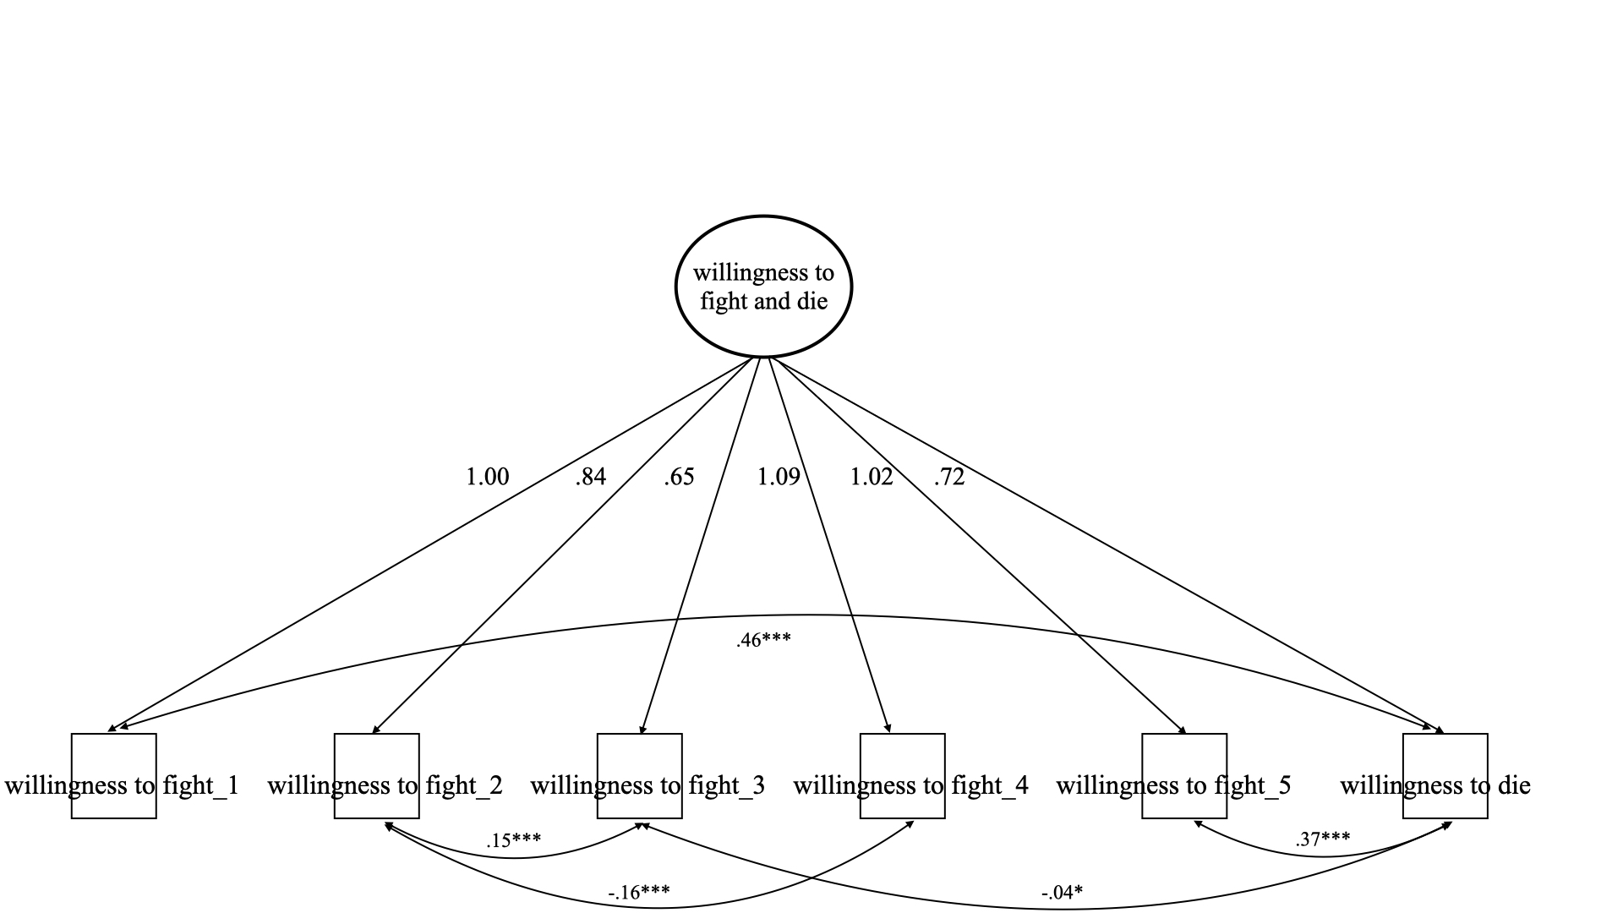

*Note. * p* < .05, *** *p* < .001

Given that willingness to fight and willingness to die appear to be best conceptualised as one rather than two distinct concepts, we performed a further exploratory analysis in which one new variable - willingness to fight/die (*α* = .78) - was introduced as the outcome variable, to be predicted by RAT and WCST accuracy rates, controlling for all previously mentioned demographic variables. Once more model fit was sub-optimal (χ2(6) = 75.70, *p* = .000; CFI = .71, RMSEA = .09 90% CI [.08, .11], SRMR = .05). As previously, we considered modification indices, and covariances between RAT accuracy rates and age as well as level of education were proposed. Introducing this additional specification, acceptable model fit was achieved (χ2(4) = 18.40, *p* = .000; CFI = .94, RMSEA = .05 90% CI [.03, .08], SRMR = .02). This model also presented a significantly better fit than the Model 1 proposed in the original study with the addition of covariances between RAT accuracy rates and age as well as level of education (χ2diff (5) = 110.38, *p* = .000). Inspecting model parameters, higher RAT but not WCST accuracy rates predicted a higher willingness to fight and die for the ingroup; the explained variance of the outcome is 7% (Figure S2). This finding replicates the original study in as far as RAT but not WCST accuracy rates are related with violent extremist behaviour intentions.

**Figure S2**

***Path model: cognitive flexibility as a predictor for willingness to fight and die***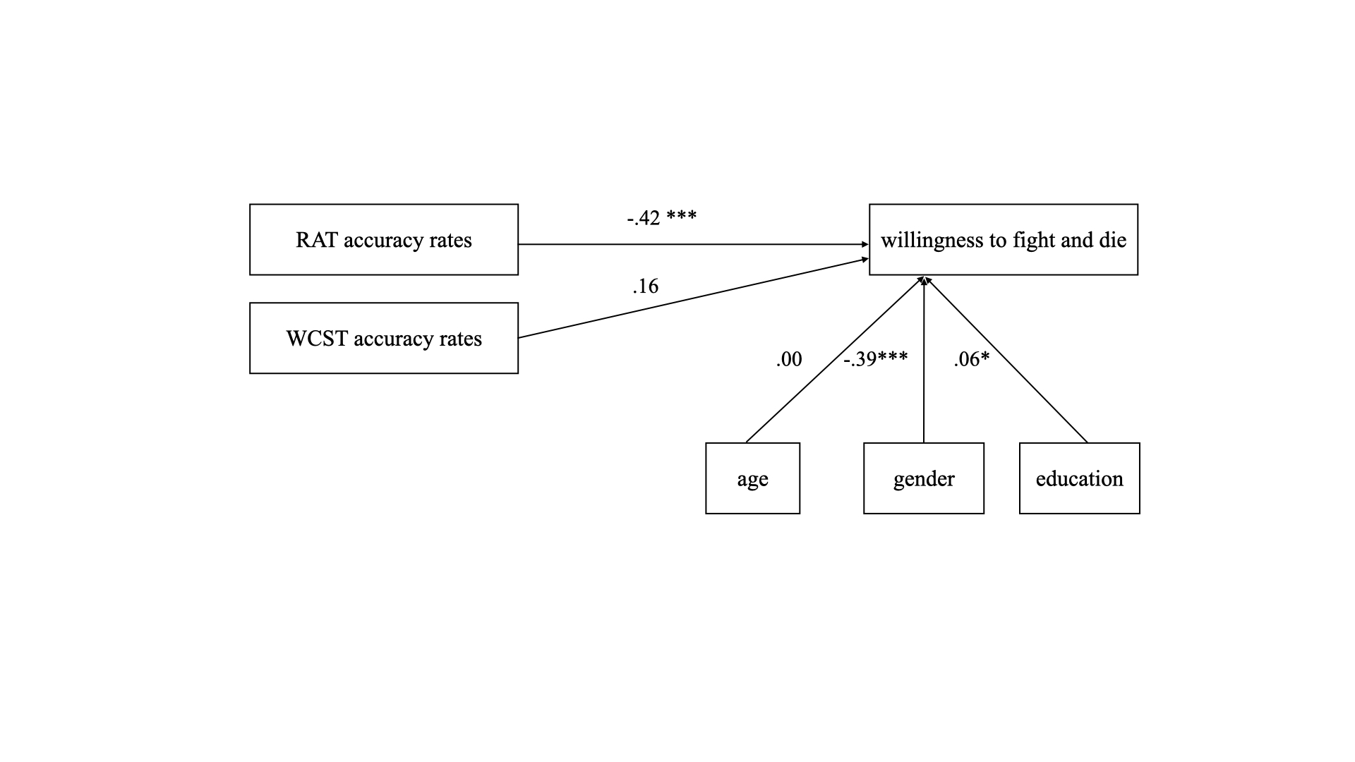

*Note. * p* < .05, *** *p* < .001

Lastly, we inspected modification indices for the models that tested whether cognitive flexibility predicted normative pro-group behaviour intentions. Once again, covariances between the residuals of RAT accuracy rates and age as well as level of education were proposed, as well as willingness to fight being regressed on gender. This adapted model attained acceptable fit (χ2(8) = 43.19, *p* = .000; CFI = .91, RMSEA = .06 90% CI [.04, .07], SRMR = .03). RAT accuracy rates were negatively related to the willingness to engage in normative pro-group behaviour; the explained variance of the outcome variable was 11% (Figure S3).

**Figure S3**

***Path model: cognitive flexibility as a predictor for normative pro-group behaviour***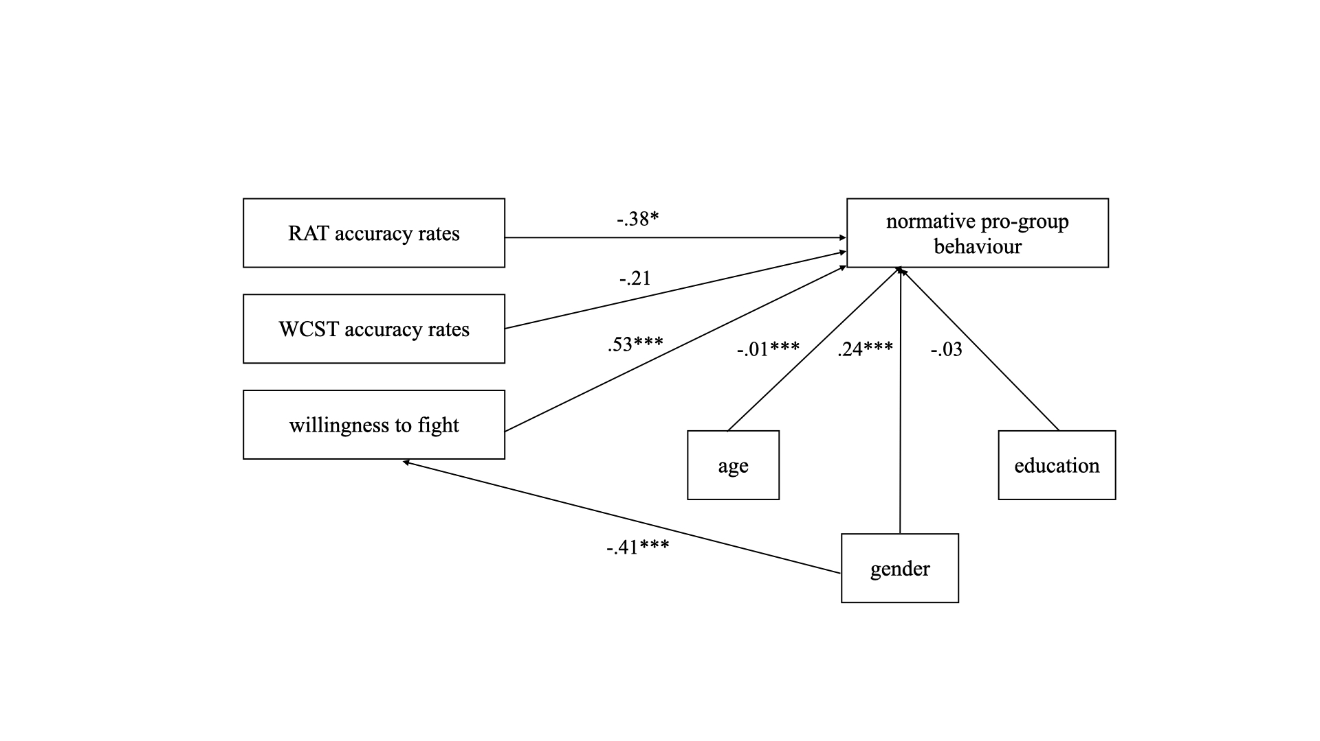

*Note. * p* < .05, *** *p* < .001

**S6: Mini meta-analysis**

We conducted a mini meta-analysis combining data from our study, the original study (Study 1, Zmigrod et al., 2019a) as well as Study 2 in Zmigrod et al. (2019a) in order to synthesis the evidence regarding a relationship between cognitive flexibility and violent extremist behaviour intentions. Using Goh et al.’s (2016) template, a fixed effects meta-analysis of three values was computed: (a) average of Spearman correlations between RAT and WCST accuracy rates, as well as Alternatives and Control CFI sub-scales and willingness to fight as well as willingness to die as identified in our study (*r* = -.04, *N* = 1378); (b) average of correlations between RAT and WCST accuracy rates and willingness to fight as well as willingness to die as identified in Study 1, Zmigrod et al. (2019a; *r = -*.18, *N* = 304); c) average of correlations between RAT and WCST accuracy rates as well as Alternative Uses Test accuracy rates and willingness to fight as well as willingness to die as identified in Study 2, Zmigrod et al. (2019a; *r* = -.12, *N* = 743). A mean correlation of *r* = -.08, 95% CI [-.12, -.04] points to a relatively small negative association.

Goh, J. X., Hall, J. A., & Rosenthal, R. (2016). Mini meta‐analysis of your own studies: Some arguments on why and a primer on how. *Social and Personality Psychology Compass*, *10*(10), 535-549. <https://doi.org/10.1111/spc3.12267>